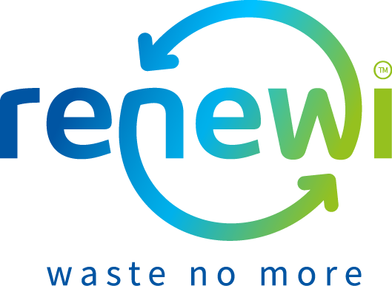
Free Recycling and Waste Minimisation Workshops for Primary Schools
Renewi have over 6 years of experience in delivering Waste Minimisation and Recycling education across the Wakefield district. The program below includes a wide range of learning activities to support both the National Curriculum and learning for sustainability. Please get in touch if you would like one of our Education Officers to visit your school, community group or event.

Our education offer is flexible. Workshops can be repeated within a school to allow more than one class to participate or we can discuss delivering two complimentary workshops to make a longer session. If you wish to use our sessions to support a particular aspect of your curriculum or a group of children with additional needs, but cannot see an appropriate session, please contact us to discuss adapting activities. Workshops can also be delivered to groups such as after school / holiday clubs or to a School Eco-Committee.
Name | Aimed at | Brief description | Maths | Science | Geography | D&T | Duration
A WEEE Solution | Yr5 - Yr6 | Did you know the average person in the UK replaces their mobile phone every 18 months? Explore the impact of the fastest growing waste stream (Waste electronics and electrical equipment) and how we can help tackle it by thinking about the way we behave as consumers and recyclers. |  | • | • | • | 60 min
Plastic? Fantastic! | Yr5 - Yr6 | Explore the different types of plastics and their everyday uses, and then explore how they are separated and recycled into clothing, like school uniforms, through hands on science experiments. |  | • |  | • | 60 min
Let’s Be…  Bin Detectives! | Yr3 - Yr6 | What does your school throw away? Pull on a pair of gloves and sort through your classroom bins. Are you really as good of a recycler as you think you are? | • | • |  |  | 60 min
Whose rubbish? | Yr3 - Yr6 | Use your investigative and critical thinking skills to discover which of four households produces the most waste and why. Then use the 3Rs to advise them on how to reduce their waste and its impacts. |  | • |  |  | 60 min
Love Lunch, Hate Waste | Yr3 - Yr6 | Does your school want to reduce its lunchtime waste? We join your pupils in understanding how packaging contributes to our waste and look both at the role of packaging and ways we can avoid it by using reusable bottles and boxes and other solutions.  If you would like to make this session part of a long term waste minimisation project in your school, please enquire about our free Enhanced Schools partnership programme. |  | • |  | • | PM sessions only  60 min
Meet The Little Rotters | Yr1 - Yr6 | Understand how we can mimic natural habitats and recycle our vegetable rubbish at home and in school. Meet our wiggly worms and make your own mini wormery experiment to take home.  Also ideal for teaching a gardening club or Eco-Committee to compost effectively. |  | • |  |  | 60 min
We can Re-USE! | Yr1 - Yr6 | Have a look through our “box of delights” containing Items that show how rubbish is recycled in Wakefield and around the world. Then have a go at making a recycled craft (age dependent), such as a tetra pak wallet, paper jewellery, a bird feeder, a bug home or a piece of recycled paper. |  | • |  | • | 20 min followed by making time in smaller groups
The Rubbish Challenge | Yr1 - Yr3 | Playing our giant floor mat game and explore the issues raised in our Exploring ways to cut waste using the 3Rs assembly below with your youngest children.  This is only suitable for delivery to half a class at a time. |  | • |  |  | 30 min per group
Assembly – Exploring ways to cut waste using the 3Rs | Yr1 - Yr6 | Explore how to cut rubbish using the 3Rs (reduce, reuse & recycle) and how this benefits the environment in an interactive assembly which uses lots of props to explain how the household recycling system works in Wakefield. |  |  |  |  | 20 min

For more information or to book a workshop or assembly please contact our Education Team at 01977 624 678 or education.wakefield@renewi.com.

