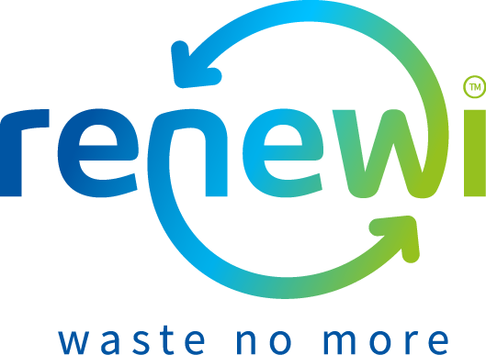
Free Recycling and Waste Minimisation Workshops for Secondary Schools
Renewi have over 6 years of experience in delivering Waste Minimisation and Recycling education across the Wakefield distract. The program below includes a wide range of learning activities to support both the National Curriculum and learning for sustainability. Please get in touch if you would like one
of our Education Officers to visit your school, community group or event.
Our education officers are flexible. Workshops can be repeated within a school to allow more than one class to participate or we can discuss delivering two complimentary workshops to make a longer session. All sessions can also be shortened to fit in with timetabling. If you wish to use our sessions to support a particular aspect of your curriculum or a group of children with additional needs, but cannot see an appropriate session, please contact us to discuss adapting activities. Workshops can also be delivered to groups such as after school clubs or to a School Eco-Committee as part of your work towards becoming an Eco-School.
Name | Aimed at  (year) | Brief description | Maths | Science | Geography | D&T | Business | Duration
Workshops which can be delivered at your school or at our Education Centre
Trendy textiles | 7 - 10 | Learn about the impacts of fashion on the environment, and how you can make a difference by making small changes when it comes to purchasing clothing. Then re-use your textiles by making a trendy shopping bag from an old t-shirt. |  |  |  | . |  | 90 min
It’s all your business – packaging | 7 - 11 | Reducing the packaging waste, you produce and zero waste alternatives. With 9 million tonnes of plastic ending up in the ocean each year it is important that we look at how our packaging is produced and what it is made from. This workshop will get students thinking about all the different types of packaging out there and how it can be changed. Students will be asked to think like a commercial buyer for a leading supermarket. They have been told that they will be fined if their packaging that isn’t recyclable. They will have to design innovative ways around this and present their business model. |  | . |  | . |  | 90 min
Love food, hate waste – the impacts of food waste and food miles | 7 – 11 | Learn about the impacts of food waste on the environment. Examine ways in which you can reduce this and grow your own food at home so that you don’t need to go to a supermarket to purchase your vegetables. Think critically about the concept of food miles and how far your food has travelled to reach your plate? What changes can be made to reduce this? |  | . |  | . |  | 90 min
Love food, hate Waste – Compleat | 7 – 11 | Hands on food technology workshop which is better in a food tech kitchen but can be delivered if necessary in a normal classroom (but recipes will be limited). Learn about the impacts of food waste on the environment and create some recipes from common food leftovers as well as how to “compleat” your food. This means eating every part of the food product which sometimes get thrown away such as cauliflower leaves, cabbage hearts and the peel of oranges and lemons. |  |  |  | . |  | 60 min
Engineering landfill challenge | 7- 11 | Students learn about the impacts of landfills and the importance of diverting rubbish away from landfill. They design and build model landfills using materials similar to those used by engineers for full-scale landfills. Their completed model landfills are "rained" on and subjected to other erosion processes. The goal is to create landfills that hold the most rubbish, minimise the cost to build and keep contaminated water inside the landfill to prevent it from causing environmental damage. Teams create designs within given a budget, test the landfills' performance, and graph and compare designs for capacity, cost and performance. |  | . |  |  |  | 90 min
Fancy a cupcake – the lifecycle of everyday products | 7-11 | Students learn about life-cycle assessment and how engineers use this technique to determine the environmental impact of everyday products. As they examine what’s involved in making and consuming cupcakes, students learn about the production, use and disposal phases of an object’s life cycle. With the class organized into teams, students calculate data for each phase of a cupcake’s life cycle—wet ingredients, dry ingredients, baking materials, oven baking, frosting, liner disposal—and calculate energy usage and greenhouse gases emitted from making one cupcake. They use ratios and fractions, and compare options for some of the life-cycle stages, such as the disposal of the wrapper (disposal to landfills or industrial composting) in order to identify a life-cycle plan with a lower environmental impact. | . | . | . |  |  | 90 min
Trash to treasure | 7-11 | Student teams use the engineering design process to create a useful product of their choice out of recyclable items and “rubbish”. The class is given a "landfill" of reusable items, such as aluminium cans, cardboard, paper, juice boxes, egg cartons, milk cartons, etc., and each group is allowed a limited amount of bonding materials, such as tape, glue and string. This activity addresses the importance of reuse and encourages students to look at ways they can reuse items they would otherwise throw away. |  |  |  | . |  | 90 min
Workshops which can only be delivered at our Education Centre
Your Rubbish, Our Resource | 7- 11 | In this session students gain an overview of the 3Rs and enter an amazing world of recycling. Get ready to be waste detectives and hunt for information around our exhibitions to learn about how we treat waste in the Wakefield area. Then get dressed up and be pickers on our interactive piece of machinery and compete against the clock just like the waste pickers do on a real conveyor line. | . | . |  |  |  | 90 min
A WEEE Solution | Yr5 - Yr6 | Did you know the average person in the UK replaces their mobile phone every 18 months? Explore the impact of the fastest growing waste stream (Waste electronics and electrical equipment) and how we can help tackle it by thinking about the way we behave as consumers and recyclers. |  |  | • | • | • | 90 min

For more information or to book a workshop or assembly please contact our Education Team at 01977 624 678 or education.wakefield@renewi.com.

