Ocean plastics sculpture competition
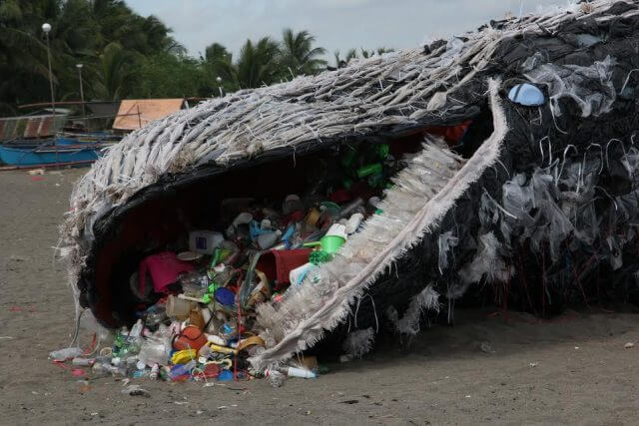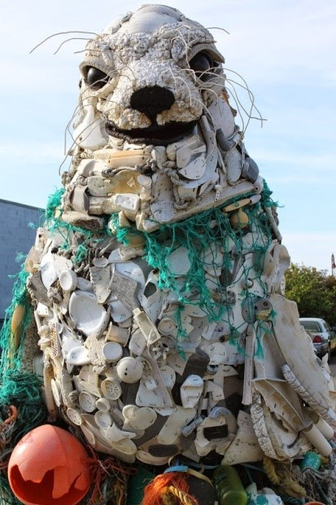
World Ocean Day 8th June 2021
World Oceans Day is held every year on the 8th of June. More than 140 countries take part and pledge to consider the importance of the ocean and the way in which we can protect it. World Oceans Day gives us the chance to spread awareness and share knowledge.
Why is it important that we take care of our oceans?
70% of the world’s surface is covered by water. Thousands of species of plants and animals live in the sea. It’s really important that we look after the sea or these plants and animals will die.
Removing plastic from the oceans around the world is a major operation, and it’s going to take a long time. Anything we can do to prevent further damage is extremely important.
The Challenge: Engie Catering Services and Renewi, working in partner with Wakefield Council, are challenging Primary Schools to design and create an ocean creature out of waste plastic which could have ended up in the local rivers and eventually in the ocean.
Context:
Plastic is cheap, long lasting and easy to produce but can cause incredible damage to our planet. By 2050, our oceans will contain more plastic than fish!
We are now producing 20 times more plastic than we did 50 years ago which could double again in the next 20 years.
Once placed into the water plastic breaks up into small particles called micro plastics. By 2050 micro plastic could be found in 99% of all seabird species!

Globally over one million water bottles are used every minute with 91% of them not being recycled. With only 9% of plastic across the world being recycled, it is more important than ever to reduce and reuse the plastics we already have on our planet to stop it from entering our ecosystems such as rivers and oceans.

The Competition

Our challenge to you is to create a sculpture of an ocean animal from waste plastics which could have ended up in our oceans. Each entry must include:
- A team name and sculpture name
- A short description on how you have decided which plastic products to use and why
- Between five and eight photos of your ocean creature including:
  - 2 full body shots
  - Photos of details to show how your group demonstrated the 3Rs whilst making your ocean animal
The ocean animal must be no taller than 150cm and be entirely freestanding.
There is no limit of entries per school
Please email your entries to
Moira Mattingley-Nunn e-mail moira.mattingley-nunn@renewi.com
Anne Kavanagh e-mail anne.kavanagh@uk.issworld.com
The competition entries must be entered by Friday 2nd July 2021 with judging taking place on Friday 9th July 2021.
All entries from the schools will be on display in the Ridings Shopping Centre from Monday 5th July 2021 – Wednesday 14th July 2021. We will collect the models from school and return them either back to the school or send them to the Renewi Centre where they will be recycled.

The winner of the ocean plastic sculpture competition will win an all-expenses paid trip, including travel, to the education centre at South Kirkby with a full day of activities based around recycling and the environment for up to 30 children tailored to your schools learning outcomes.

Good luck!

